Create a web app with ASP.NET Core MVC on Windows with Visual Studio
- 26/10/2017
- By Rick Anderson
- https://docs.microsoft.com/en-us/aspnet/core/tutorials/first-mvc-app/start-mvc
This tutorial teaches ASP.NET Core MVC web development with controllers and views. Razor Pages is a new alternative in ASP.NET Core 2.0, a page-based programming model that makes building web UI easier and more productive. We recommend you try the Razor Pages tutorial before the MVC version. The Razor Pages tutorial:
- Is the preferred approach for new application development.
- Is easier to follow.
- Covers more features.
There are 3 versions of this tutorial:
- Windows: This series
- macOS: Create an ASP.NET Core MVC app with Visual Studio for Mac
- macOS, Linux, and Windows: Create an ASP.NET Core MVC app with Visual Studio Code
The tutorial series includes the following:
- Get started
- Add a controller
- Add a view
- Add a model
- Work with SQL Server LocalDB
- Controller methods and views
- Add search
- Add a new field
- Add validation
- Examine the Details and Delete methods

Get started with ASP.NET Core MVC and Visual Studio
This tutorial teaches ASP.NET Core MVC web development with controllers and views. Razor Pages is a new alternative in ASP.NET Core 2.0, a page-based programming model that makes building web UI easier and more productive. We recommend you try the Razor Pages tutorial before the MVC version. The Razor Pages tutorial:
- Is the preferred approach for new application development.
- Is easier to follow.
- Covers more features.

Install Visual Studio and .NET Core
Install one of the following:
- CLI tooling: Windows, Linux, or macOS: .NET Core SDK 2.0 or later
- IDE/editor tooling
  - Windows: Visual Studio for Windows
    - ASP.NET and web development workload
    - .NET Core cross-platform development workload
  - Linux: Visual Studio Code
  - macOS: Visual Studio for Mac

Create a web app
From Visual Studio, select File > New > Project.
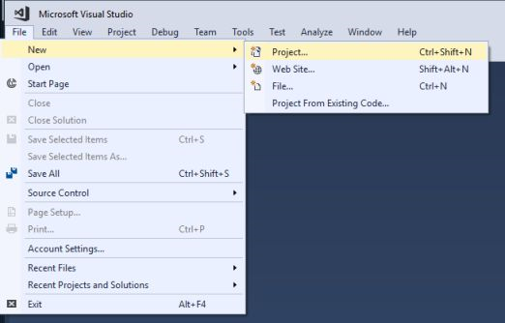
Complete the New Project dialog:
- In the left pane, tap .NET Core
- In the center pane, tap ASP.NET Core Web Application (.NET Core)
- Name the project "MvcMovie" (It's important to name the project "MvcMovie" so when you copy code, the namespace will match.)
- Tap OK
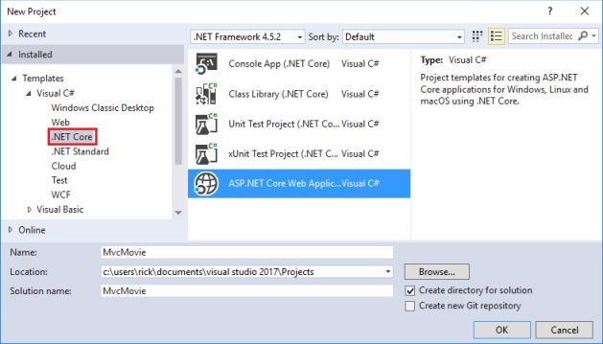

Complete the New ASP.NET Core Web Application (.NET Core) - MvcMovie dialog:
- In the version selector drop-down box select ASP.NET Core 2.-
- Select Web Application(Model-View-Controller)
- Tap OK.
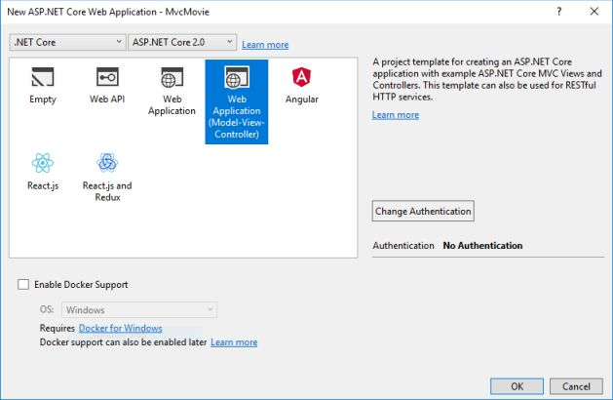
Visual Studio used a default template for the MVC project you just created. You have a working app right now by entering a project name and selecting a few options. This is a simple starter project, and it's a good place to start,
Tap F5 to run the app in debug mode or Ctrl-F5 in non-debug mode.
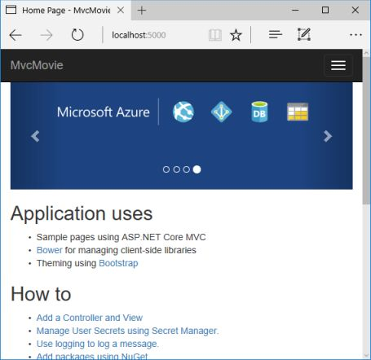
- Visual Studio starts IIS Express and runs your app. Notice that the address bar shows localhost:port# and not something like example.com. That's because localhost is the standard hostname for your local computer. When Visual Studio creates a web project, a random port is used for the web server. In the image above, the port number is 5000. The URL in the browser shows localhost:5000. When you run the app, you'll see a different port number.
- Launching the app with Ctrl+F5 (non-debug mode) allows you to make code changes, save the file, refresh the browser, and see the code changes. Many developers prefer to use non-debug mode to quickly launch the app and view changes.
- You can launch the app in debug or non-debug mode from the Debug menu item:
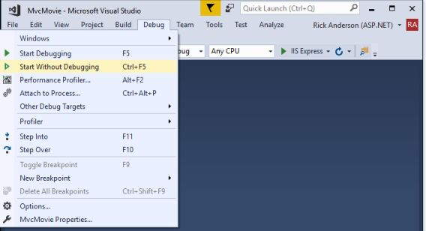

- You can debug the app by tapping the IIS Express button
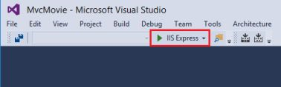
The default template gives you working Home, About and Contact links. The browser image above doesn't show these links. Depending on the size of your browser, you might need to click the navigation icon to show them.
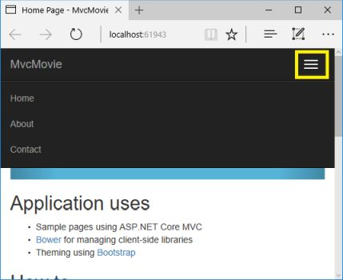
If you were running in debug mode, tap Shift-F5 to stop debugging.
In the next part of this tutorial, we'll learn about MVC and start writing some code.

Add a controller to an ASP.NET Core MVC app
The Model-View-Controller (MVC) architectural pattern separates an app into three main components: Model, View, and Controller. The MVC pattern helps you create apps that are more testable and easier to update than traditional monolithic apps. MVC-based apps contain:
- Models: Classes that represent the data of the app. The model classes use validation logic to enforce business rules for that data. Typically, model objects retrieve and store model state in a database. In this tutorial, a Movie model retrieves movie data from a database, provides it to the view or updates it. Updated data is written to a database.
- Views: Views are the components that display the app's user interface (UI). Generally, this UI displays the model data.
- Controllers: Classes that handle browser requests. They retrieve model data and call view templates that return a response. In an MVC app, the view only displays information; the controller handles and responds to user input and interaction. For example, the controller handles route data and query-string values, and passes these values to the model. The model might use these values to query the database. For example, http://localhost:1234/Home/About has route data of Home (the controller) and About (the action method to call on the home controller). http://localhost:1234/Movies/Edit/5 is a request to edit the movie with ID=5 using the movie controller. We'll talk about route data later in the tutorial.
The MVC pattern helps you create apps that separate the different aspects of the app (input logic, business logic, and UI logic), while providing a loose coupling between these elements. The pattern specifies where each kind of logic should be located in the app. The UI logic belongs in the view. Input logic belongs in the controller. Business logic belongs in the model. This separation helps you manage complexity when you build an app, because it enables you to work on one aspect of the implementation at a time without impacting the code of another. For example, you can work on the view code without depending on the business logic code.
We cover these concepts in this tutorial series and show you how to use them to build a movie app. The MVC project contains folders for the Controllers and Views.
- In Solution Explorer, right-click Controllers > Add > New Item
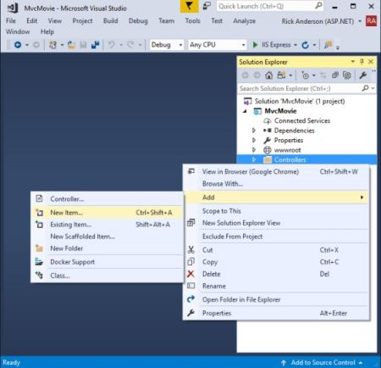
- elect Controller Class
- In the Add New Item dialog, enter HelloWorldController.
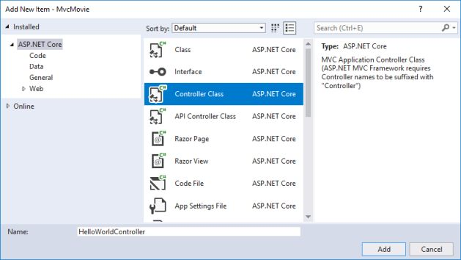
Replace the contents of Controllers/HelloWorldController.cs with the following:
using Microsoft.AspNetCore.Mvc;
using System.Text.Encodings.Web;

namespace MvcMovie.Controllers
{
public class HelloWorldController : Controller
{
//
// GET: /HelloWorld/

public string Index()
{
return "This is my default action...";
}

//
// GET: /HelloWorld/Welcome/

public string Welcome()
{
return "This is the Welcome action method...";
}
}
}
Every public method in a controller is callable as an HTTP endpoint. In the sample above, both methods return a string. Note the comments preceding each method.
An HTTP endpoint is a targetable URL in the web application, such as http://localhost:1234/HelloWorld, and combines the protocol used: HTTP, the network location of the web server (including the TCP port): localhost:1234 and the target URI HelloWorld.
The first comment states this is an HTTP GET method that's invoked by appending "/HelloWorld/" to the base URL. The second comment specifies an HTTP GET method that's invoked by appending "/HelloWorld/Welcome/" to the URL. Later on in the tutorial you'll use the scaffolding engine to generate HTTP POST methods.
Run the app in non-debug mode and append "HelloWorld" to the path in the address bar. The Index method returns a string.
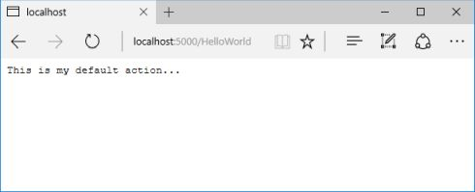
MVC invokes controller classes (and the action methods within them) depending on the incoming URL. The default URL routing logic used by MVC uses a format like this to determine what code to invoke:
/[Controller]/[ActionName]/[Parameters]
You set the format for routing in the Configure method in Startup.cs file.
app.UseMvc(routes =>
{
routes.MapRoute(
name: "default",
template: "{controller=Home}/{action=Index}/{id?}");
});
When you run the app and don't supply any URL segments, it defaults to the "Home" controller and the "Index" method specified in the template line highlighted above.
The first URL segment determines the controller class to run. So localhost:xxxx/HelloWorld maps to the HelloWorldController class. The second part of the URL segment determines the action method on the class. So localhost:xxxx/HelloWorld/Index would cause the Index method of the HelloWorldController class to run. Notice that you only had to browse to localhost:xxxx/HelloWorld and the Index method was called by default. This is because Index is the default method that will be called on a controller if a method name isn't explicitly specified. The third part of the URL segment ( id) is for route data. You'll see route data later on in this tutorial.
Browse to http://localhost:xxxx/HelloWorld/Welcome. The Welcome method runs and returns the string "This is the Welcome action method...". For this URL, the controller is HelloWorld and Welcome is the action method. You haven't used the [Parameters] part of the URL yet.
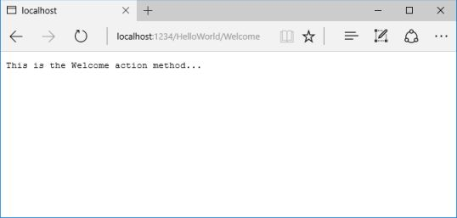
Modify the code to pass some parameter information from the URL to the controller. For example, /HelloWorld/Welcome?name=Rick&numtimes=4. Change the Welcome method to include two parameters as shown in the following code.
// GET: /HelloWorld/Welcome/
// Requires using System.Text.Encodings.Web;
public string Welcome(string name, int numTimes = 1)
{
return HtmlEncoder.Default.Encode($"Hello {name}, NumTimes is: {numTimes}");
}
The preceding code:
- Uses the C# optional-parameter feature to indicate that the numTimes parameter defaults to 1 if no value is passed for that parameter.
- UsesHtmlEncoder.Default.Encode to protect the app from malicious input (namely JavaScript).
- Uses Interpolated Strings.
Run your app and browse to:
http://localhost:xxxx/HelloWorld/Welcome?name=Rick&numtimes=4
(Replace xxxx with your port number.) You can try different values for name and numtimes in the URL. The MVC model binding system automatically maps the named parameters from the query string in the address bar to parameters in your method. See Model Binding for more information.
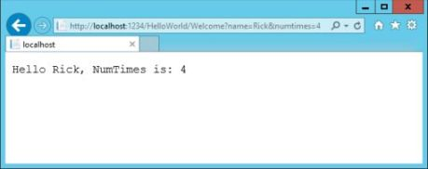
In the image above, the URL segment (Parameters) isn't used, the name and numTimes parameters are passed as query strings. The ? (question mark) in the above URL is a separator, and the query strings follow. The & character separates query strings.
Replace the Welcome method with the following code:
public string Welcome(string name, int ID = 1)
{
return HtmlEncoder.Default.Encode($"Hello {name}, ID: {ID}");
}
Run the app and enter the following URL: http://localhost:xxx/HelloWorld/Welcome/3?name=Rick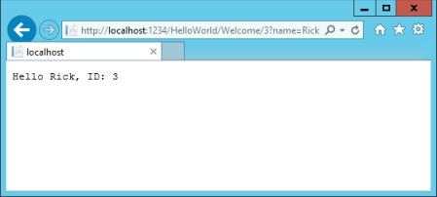
This time the third URL segment matched the route parameter id. The Welcome method contains a parameter id that matched the URL template in the MapRoute method. The trailing ? (in id?) indicates the id parameter is optional.
app.UseMvc(routes =>
{
routes.MapRoute(
name: "default",
template: "{controller=Home}/{action=Index}/{id?}");
});
In these examples the controller has been doing the "VC" portion of MVC - that is, the view and controller work. The controller is returning HTML directly. Generally you don't want controllers returning HTML directly, since that becomes very cumbersome to code and maintain. Instead you typically use a separate Razor view template file to help generate the HTML response. You do that in the next tutorial.
In Visual Studio, in non-debug mode (Ctrl+F5), you don't need to build the app after changing code. Just save the file, refresh your browser and you can see the changes.

Adding a view to an ASP.NET Core MVC app
In this section you modify the HelloWorldController class to use Razor view template files to cleanly encapsulate the process of generating HTML responses to a client.
You create a view template file using Razor. Razor-based view templates have a .cshtml file extension. They provide an elegant way to create HTML output using C#.
Currently the Index method returns a string with a message that's hard-coded in the controller class. In the HelloWorldController class, replace the Index method with the following code:
public IActionResult Index()
{
return View();
}
The preceding code returns a View object. It uses a view template to generate an HTML response to the browser. Controller methods (also known as action methods) such as the Index method above, generally return an IActionResult (or a class derived from ActionResult), not a type like string.
- Right click on the Views folder, and then Add > New Folder and name the folder HelloWorld.
- Right click on the Views/HelloWorld folder, and then Add > New Item.
- In the Add New Item - MvcMovie dialog
  - In the search box in the upper-right, enter view
  - Tap Razor View
  - In the Name box, change the name if necessary to Index.cshtml.
  - Tap Add
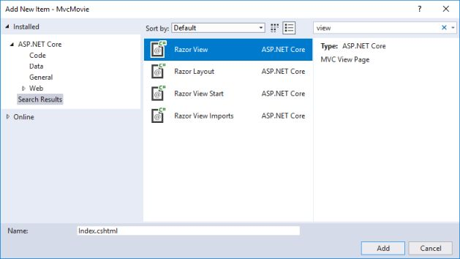
Replace the contents of the Views/HelloWorld/Index.cshtml Razor view file with the following:
@{
ViewData["Title"] = "Index";
}

<h2>Index</h2>

<p>Hello from our View Template!</p>
Navigate to http://localhost:xxxx/HelloWorld. The Index method in the HelloWorldController didn't do much; it ran the statement return View();, which specified that the method should use a view template file to render a response to the browser. Because you didn't explicitly specify the name of the view template file, MVC defaulted to using the Index.cshtml view file in the /Views/HelloWorld folder. The image below shows the string "Hello from our View Template!" hard-coded in the view.
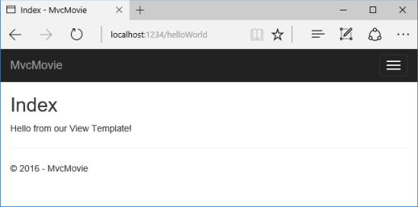
If your browser window is small (for example on a mobile device), you might need to toggle (tap) the Bootstrap navigation button in the upper right to see the Home, About, and Contact links.
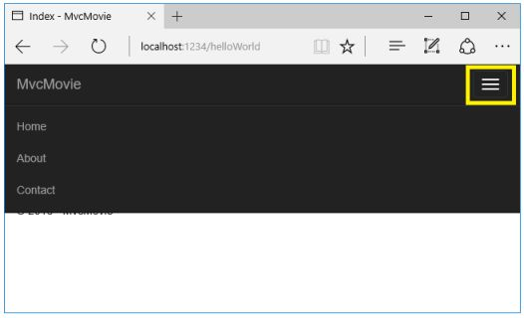

Changing views and layout pages
Tap the menu links (MvcMovie, Home, About). Each page shows the same menu layout. The menu layout is implemented in the Views/Shared/_Layout.cshtml file. Open the Views/Shared/_Layout.cshtml file.
Layout templates allow you to specify the HTML container layout of your site in one place and then apply it across multiple pages in your site. Find the @RenderBody() line. RenderBody is a placeholder where all the view-specific pages you create show up, wrapped in the layout page. For example, if you select the About link, the Views/Home/About.cshtml view is rendered inside the RenderBody method.

Change the title and menu link in the layout file
In the title element, change MvcMovie to Movie App. Change the anchor text in the layout template from MvcMovie to Movie App and the controller from Home to Movies as highlighted below:
Note: The ASP.NET Core 2.0 version is slightly different. It doesn't contain @inject ApplicationInsights and @Html.Raw(JavaScriptSnippet.FullScript).
@inject Microsoft.ApplicationInsights.AspNetCore.JavaScriptSnippet JavaScriptSnippet
<!DOCTYPE html>
<html>
<head>
<meta charset="utf-8" />
<meta name="viewport" content="width=device-width, initial-scale=1.0" />
<title>@ViewData["Title"] - Movie App</title>

<environment names="Development">
<link rel="stylesheet" href="~/lib/bootstrap/dist/css/bootstrap.css" />
<link rel="stylesheet" href="~/css/site.css" />
</environment>
<environment names="Staging,Production">
<link rel="stylesheet" href="https://ajax.aspnetcdn.com/ajax/bootstrap/3.3.7/css/bootstrap.min.css"
asp-fallback-href="~/lib/bootstrap/dist/css/bootstrap.min.css"
asp-fallback-test-class="sr-only" asp-fallback-test-property="position" asp-fallback-test-value="absolute" />
<link rel="stylesheet" href="~/css/site.min.css" asp-append-version="true" />
</environment>
@Html.Raw(JavaScriptSnippet.FullScript)
</head>
<body>
<nav class="navbar navbar-inverse navbar-fixed-top">
<div class="container">
<div class="navbar-header">
<button type="button" class="navbar-toggle" data-toggle="collapse" data-target=".navbar-collapse">
<span class="sr-only">Toggle navigation</span>
<span class="icon-bar"></span>
<span class="icon-bar"></span>
<span class="icon-bar"></span>
</button>
<a asp-area="" asp-controller="Movies" asp-action="Index" class="navbar-brand">Movie App</a>
</div>
<div class="navbar-collapse collapse">
<ul class="nav navbar-nav">
<li><a asp-area="" asp-controller="Home" asp-action="Index">Home</a></li>
<li><a asp-area="" asp-controller="Home" asp-action="About">About</a></li>
<li><a asp-area="" asp-controller="Home" asp-action="Contact">Contact</a></li>
</ul>
</div>
</div>
</nav>
<div class="container body-content">
@RenderBody()
<hr />
<footer>
<p>&copy; 2017 - MvcMovie</p>
</footer>
</div>

<environment names="Development">
<script src="~/lib/jquery/dist/jquery.js"></script>
<script src="~/lib/bootstrap/dist/js/bootstrap.js"></script>
<script src="~/js/site.js" asp-append-version="true"></script>
</environment>
<environment names="Staging,Production">
<script src="https://ajax.aspnetcdn.com/ajax/jquery/jquery-2.2.0.min.js"
asp-fallback-src="~/lib/jquery/dist/jquery.min.js"
asp-fallback-test="window.jQuery"
crossorigin="anonymous"
integrity="sha384-K+ctZQ+LL8q6tP7I94W+qzQsfRV2a+AfHIi9k8z8l9ggpc8X+Ytst4yBo/hH+8Fk">
</script>
<script src="https://ajax.aspnetcdn.com/ajax/bootstrap/3.3.7/bootstrap.min.js"
asp-fallback-src="~/lib/bootstrap/dist/js/bootstrap.min.js"
asp-fallback-test="window.jQuery && window.jQuery.fn && window.jQuery.fn.modal"
crossorigin="anonymous"
integrity="sha384-Tc5IQib027qvyjSMfHjOMaLkfuWVxZxUPnCJA7l2mCWNIpG9mGCD8wGNIcPD7Txa">
</script>
<script src="~/js/site.min.js" asp-append-version="true"></script>
</environment>

@RenderSection("Scripts", required: false)
</body>
</html>
Warning
We haven't implemented the Movies controller yet, so if you click on that link, you'll get a 404 (Not found) error.
Save your changes and tap the About link. Notice how the title on the browser tab now displays About - Movie App instead of About - Mvc Movie:
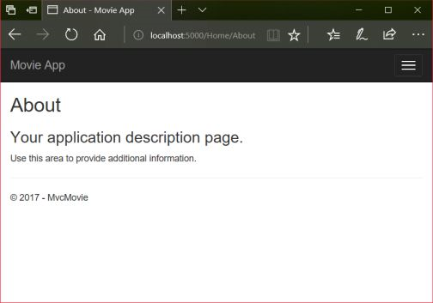
Tap the Contact link and notice that the title and anchor text also display Movie App. We were able to make the change once in the layout template and have all pages on the site reflect the new link text and new title.
Examine the Views/_ViewStart.cshtml file:
@{
Layout = "_Layout";
}
The Views/_ViewStart.cshtml file brings in the Views/Shared/_Layout.cshtml file to each view. You can use the Layout property to set a different layout view, or set it to null so no layout file will be used.
Change the title of the Index view.
Open Views/HelloWorld/Index.cshtml. There are two places to make a change:
- The text that appears in the title of the browser.
- The secondary header (<h2> element).
You'll make them slightly different so you can see which bit of code changes which part of the app.
@{
ViewData["Title"] = "Movie List";
}

<h2>My Movie List</h2>

<p>Hello from our View Template!</p>
ViewData["Title"] = "Movie List"; in the code above sets the Title property of the ViewData dictionary to "Movie List". The Title property is used in the <title> HTML element in the layout page:
<title>@ViewData["Title"] - Movie App</title>
Save your change and navigate to http://localhost:xxxx/HelloWorld. Notice that the browser title, the primary heading, and the secondary headings have changed. (If you don't see changes in the browser, you might be viewing cached content. Press Ctrl+F5 in your browser to force the response from the server to be loaded.) The browser title is created with ViewData["Title"] we set in the Index.cshtml view template and the additional "- Movie App" added in the layout file.
Also notice how the content in the Index.cshtml view template was merged with the Views/Shared/_Layout.cshtml view template and a single HTML response was sent to the browser. Layout templates make it really easy to make changes that apply across all of the pages in your application. To learn more see Layout.
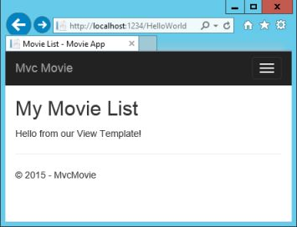
Our little bit of "data" (in this case the "Hello from our View Template!" message) is hard-coded, though. The MVC application has a "V" (view) and you've got a "C" (controller), but no "M" (model) yet.

Passing Data from the Controller to the View
Controller actions are invoked in response to an incoming URL request. A controller class is where you write the code that handles the incoming browser requests. The controller retrieves data from a data source and decides what type of response to send back to the browser. View templates can be used from a controller to generate and format an HTML response to the browser.
Controllers are responsible for providing the data required in order for a view template to render a response. A best practice: View templates should not perform business logic or interact with a database directly. Rather, a view template should work only with the data that's provided to it by the controller. Maintaining this "separation of concerns" helps keep your code clean, testable, and maintainable.
Currently, the Welcome method in the HelloWorldController class takes a name and a ID parameter and then outputs the values directly to the browser. Rather than have the controller render this response as a string, change the controller to use a view template instead. The view template generates a dynamic response, which means that appropriate bits of data must be passed from the controller to the view in order to generate the response. Do this by having the controller put the dynamic data (parameters) that the view template needs in a ViewData dictionary that the view template can then access.
Return to the HelloWorldController.cs file and change the Welcome method to add a Message and NumTimes value to the ViewData dictionary. The ViewData dictionary is a dynamic object, which means you can put whatever you want in to it; the ViewData object has no defined properties until you put something inside it. The MVC model binding system automatically maps the named parameters (name and numTimes) from the query string in the address bar to parameters in your method. The complete HelloWorldController.cs file looks like this:
using Microsoft.AspNetCore.Mvc;
using System.Text.Encodings.Web;

namespace MvcMovie.Controllers
{
public class HelloWorldController : Controller
{
public IActionResult Index()
{
return View();
}

public IActionResult Welcome(string name, int numTimes = 1)
{
ViewData["Message"] = "Hello " + name;
ViewData["NumTimes"] = numTimes;

return View();
}
}
}
The ViewData dictionary object contains data that will be passed to the view.
Create a Welcome view template named Views/HelloWorld/Welcome.cshtml.
You'll create a loop in the Welcome.cshtml view template that displays "Hello" NumTimes. Replace the contents of Views/HelloWorld/Welcome.cshtmlwith the following:
@{
ViewData["Title"] = "Welcome";
}

<h2>Welcome</h2>

<ul>
@for (int i = 0; i < (int)ViewData["NumTimes"]; i++)
{
<li>@ViewData["Message"]</li>
}
</ul>
Save your changes and browse to the following URL:
http://localhost:xxxx/HelloWorld/Welcome?name=Rick&numtimes=4
Data is taken from the URL and passed to the controller using the MVC model binder . The controller packages the data into a ViewData dictionary and passes that object to the view. The view then renders the data as HTML to the browser.
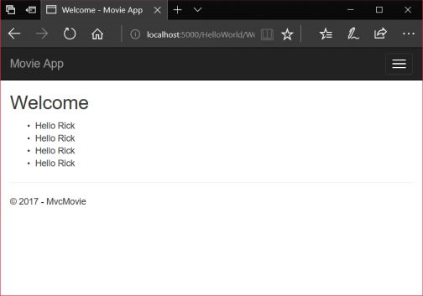
In the sample above, we used the ViewData dictionary to pass data from the controller to a view. Later in the tutorial, we will use a view model to pass data from a controller to a view. The view model approach to passing data is generally much preferred over the ViewData dictionary approach. See ViewModel vs ViewData vs ViewBag vs TempData vs Session in MVC for more information.
Well, that was a kind of an "M" for model, but not the database kind. Let's take what we've learned and create a database of movies.

Adding a model to an ASP.NET Core MVC app
In this section, you'll add some classes for managing movies in a database. These classes will be the "Model" part of the MVC app.
You use these classes with Entity Framework Core (EF Core) to work with a database. EF Core is an object-relational mapping (ORM) framework that simplifies the data access code that you have to write. EF Core supports many database engines.
The model classes you'll create are known as POCO classes (from "plain-old CLR objects") because they don't have any dependency on EF Core. They just define the properties of the data that will be stored in the database.
In this tutorial you'll write the model classes first, and EF Core will create the database. An alternate approach not covered here is to generate model classes from an already-existing database. For information about that approach, see ASP.NET Core - Existing Database.

Add a data model class
Note: The ASP.NET Core 2.0 templates contain the Models folder.
Right-click the Models folder > Add > Class. Name the class Movie and add the following properties:
using System;

namespace MvcMovie.Models
{
public class Movie
{
public int ID { get; set; }
public string Title { get; set; }
public DateTime ReleaseDate { get; set; }
public string Genre { get; set; }
public decimal Price { get; set; }
}
}
The ID field is required by the database for the primary key.
Build the project to verify you don't have any errors. You now have a Model in your MVC app.

Scaffolding a controller
In Solution Explorer, right-click the Controllers folder > Add > Controller.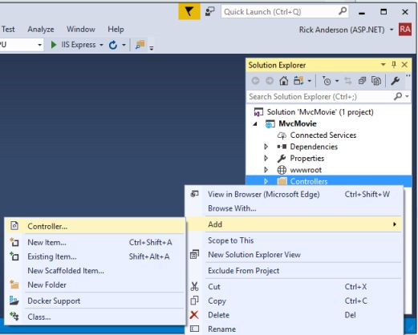
If the Add MVC Dependencies dialog appears:
- Update Visual Studio to the latest version. Visual Studio versions prior to 15.5 show this dialog.
- If you can't update, select ADD, and then follow the add controller steps again.
In the Add Scaffold dialog, tap MVC Controller with views, using Entity Framework > Add.
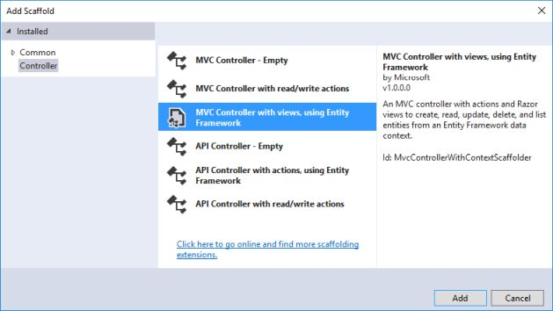
Complete the Add Controller dialog:
- Model class: Movie (MvcMovie.Models)
- Data context class: Select the + icon and add the default MvcMovie.Models.MvcMovieContext
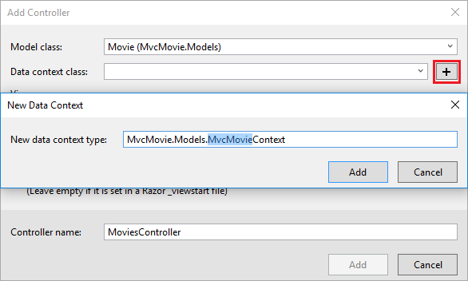
- Views: Keep the default of each option checked
- Controller name: Keep the default MoviesController
- Tap Add
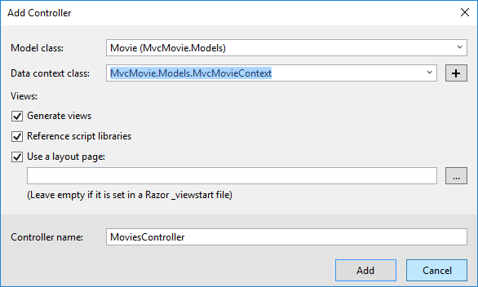
Visual Studio creates:
- An Entity Framework Core database context class (Data/MvcMovieContext.cs)
- A movies controller (Controllers/MoviesController.cs)
- Razor view files for Create, Delete, Details, Edit, and Index pages (Views/Movies/*.cshtml)
The automatic creation of the database context and CRUD (create, read, update, and delete) action methods and views is known as scaffolding. You'll soon have a fully functional web application that lets you manage a movie database.
If you run the app and click on the Mvc Movie link, you get an error similar to the following:
An unhandled exception occurred while processing the request.

SqlException: Cannot open database "MvcMovieContext-<GUID removed>" requested by the login. The login failed.
Login failed for user 'Rick'.

System.Data.SqlClient.SqlInternalConnectionTds..ctor(DbConnectionPoolIdentity identity, SqlConnectionString
You need to create the database, and you'll use the EF Core Migrations feature to do that. Migrations lets you create a database that matches your data model and update the database schema when your data model changes.

Add EF tooling and perform initial migration
In this section you'll use the Package Manager Console (PMC) to:
- Add the Entity Framework Core Tools package. This package is required to add migrations and update the database.
- Add an initial migration.
- Update the database with the initial migration.
From the Tools menu, select NuGet Package Manager > Package Manager Console.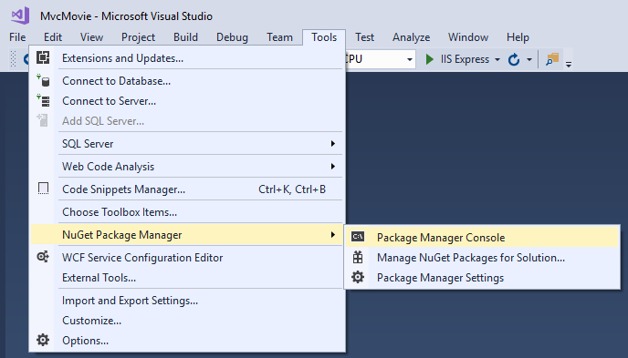
In the PMC, enter the following commands:
Install-Package Microsoft.EntityFrameworkCore.Tools
Add-Migration Initial
Update-Database
Note: If you receive an error with the Install-Package command, open NuGet Package Manager and search for the Microsoft.EntityFrameworkCore.Tools package. This allows you to install the package or check if it's already installed. Alternatively, see the CLI approach if you have problems with the PMC.
The Add-Migration command creates code to create the initial database schema. The schema is based on the model specified in the DbContext(In the Data/MvcMovieContext.cs file). The Initial argument is used to name the migrations. You can use any name, but by convention you choose a name that describes the migration. See Introduction to migrations for more information.
The Update-Database command runs the Up method in the Migrations/<time-stamp>_Initial.cs file, which creates the database.
You can perform the preceeding steps using the command-line interface (CLI) rather than the PMC:
- Add EF Core tooling to the .csproj file.
- Run the following commands from the console (in the project directory):
dotnet ef migrations add Initial
dotnet ef database update
If you run the app and get the error:
SqlException: Cannot open database "Movie" requested by the login.
The login failed.
Login failed for user 'user name'.
You probably have not run dotnet ef database update.

Test the app
- Run the app and tap the Mvc Movie link.
- Tap the Create New link and create a movie.
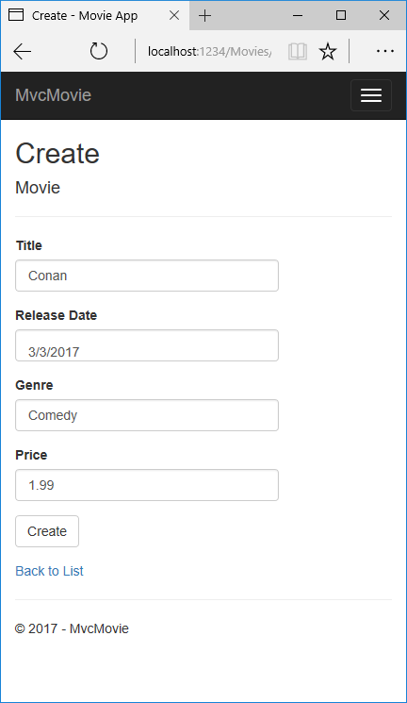
- You may not be able to enter decimal points or commas in the Price field. To support jQuery validation for non-English locales that use a comma (",") for a decimal point, and non US-English date formats, you must take steps to globalize your app. See https://github.com/aspnet/Docs/issues/4076 and Additional resources for more information. For now, just enter whole numbers like 10.

- In some locales you need to specify the date format. See the highlighted code below.
using System;
using System.ComponentModel.DataAnnotations;

namespace MvcMovie.Models
{
public class Movie
{
public int ID { get; set; }
public string Title { get; set; }
[DisplayFormat(DataFormatString = "{0:yyyy-MM-dd}", ApplyFormatInEditMode = true)]
public DateTime ReleaseDate { get; set; }
public string Genre { get; set; }
public decimal Price { get; set; }
}
}
We'll talk about DataAnnotations later in the tutorial.
Tapping Create causes the form to be posted to the server, where the movie information is saved in a database. The app redirects to the /MoviesURL, where the newly created movie information is displayed.
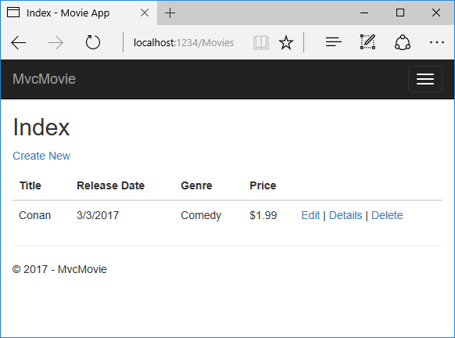
Create a couple more movie entries. Try the Edit, Details, and Delete links, which are all functional.
public void ConfigureServices(IServiceCollection services)
{
// Add framework services.
services.AddMvc();

services.AddDbContext<MvcMovieContext>(options =>
options.UseSqlServer(Configuration.GetConnectionString("MvcMovieContext")));
}
The highlighted code above shows the movie database context being added to the Dependency Injection container (In the Startup.cs file). services.AddDbContext<MvcMovieContext>(options => specifies the database to use and the connection string. => is a lambda operator.
Open the Controllers/MoviesController.cs file and examine the constructor:
public class MoviesController : Controller
{
private readonly MvcMovieContext _context;

public MoviesController(MvcMovieContext context)
{
_context = context;
}
The constructor uses Dependency Injection to inject the database context (MvcMovieContext) into the controller. The database context is used in each of the CRUD methods in the controller.

Strongly typed models and the @model keyword
Earlier in this tutorial, you saw how a controller can pass data or objects to a view using the ViewData dictionary. The ViewData dictionary is a dynamic object that provides a convenient late-bound way to pass information to a view.
MVC also provides the ability to pass strongly typed model objects to a view. This strongly typed approach enables better compile-time checking of your code. The scaffolding mechanism used this approach (that is, passing a strongly typed model) with the MoviesController class and views when it created the methods and views.
Examine the generated Details method in the Controllers/MoviesController.cs file:
// GET: Movies/Details/5
public async Task<IActionResult> Details(int? id)
{
if (id == null)
{
return NotFound();
}

var movie = await _context.Movie
.SingleOrDefaultAsync(m => m.ID == id);
if (movie == null)
{
return NotFound();
}

return View(movie);
}
The id parameter is generally passed as route data. For example http://localhost:5000/movies/details/1 sets:
- The controller to the movies controller (the first URL segment).
- The action to details (the second URL segment).
- The id to 1 (the last URL segment).
You can also pass in the id with a query string as follows:
http://localhost:1234/movies/details?id=1
The id parameter is defined as a nullable type (int?) in case an ID value isn't provided.
A lambda expression is passed in to SingleOrDefaultAsync to select movie entities that match the route data or query string value.
var movie = await _context.Movie
.SingleOrDefaultAsync(m => m.ID == id);
If a movie is found, an instance of the Movie model is passed to the Details view:
return View(movie);
Examine the contents of the Views/Movies/Details.cshtml file:
@model MvcMovie.Models.Movie

@{
ViewData["Title"] = "Details";
}

<h2>Details</h2>

<div>
<h4>Movie</h4>
<hr />
<dl class="dl-horizontal">
<dt>
@Html.DisplayNameFor(model => model.Title)
</dt>
<dd>
@Html.DisplayFor(model => model.Title)
</dd>
<dt>
@Html.DisplayNameFor(model => model.ReleaseDate)
</dt>
<dd>
@Html.DisplayFor(model => model.ReleaseDate)
</dd>
<dt>
@Html.DisplayNameFor(model => model.Genre)
</dt>
<dd>
@Html.DisplayFor(model => model.Genre)
</dd>
<dt>
@Html.DisplayNameFor(model => model.Price)
</dt>
<dd>
@Html.DisplayFor(model => model.Price)
</dd>
</dl>
</div>
<div>
<a asp-action="Edit" asp-route-id="@Model.ID">Edit</a> |
<a asp-action="Index">Back to List</a>
</div>
By including a @model statement at the top of the view file, you can specify the type of object that the view expects. When you created the movie controller, Visual Studio automatically included the following @model statement at the top of the Details.cshtml file:
@model MvcMovie.Models.Movie
This @model directive allows you to access the movie that the controller passed to the view by using a Model object that's strongly typed. For example, in the Details.cshtml view, the code passes each movie field to the DisplayNameFor and DisplayFor HTML Helpers with the strongly typed Model object. The Create and Edit methods and views also pass a Movie model object.
Examine the Index.cshtml view and the Index method in the Movies controller. Notice how the code creates a List object when it calls the Viewmethod. The code passes this Movies list from the Index action method to the view:
// GET: Movies
public async Task<IActionResult> Index()
{
return View(await _context.Movie.ToListAsync());
}
When you created the movies controller, scaffolding automatically included the following @model statement at the top of the Index.cshtml file:
@model IEnumerable<MvcMovie.Models.Movie>
The @model directive allows you to access the list of movies that the controller passed to the view by using a Model object that's strongly typed. For example, in the Index.cshtml view, the code loops through the movies with a foreach statement over the strongly typed Model object:
@model IEnumerable<MvcMovie.Models.Movie>

@{
ViewData["Title"] = "Index";
}

<h2>Index</h2>

<p>
<a asp-action="Create">Create New</a>
</p>
<table class="table">
<thead>
<tr>
<th>
@Html.DisplayNameFor(model => model.Title)
</th>
<th>
@Html.DisplayNameFor(model => model.ReleaseDate)
</th>
<th>
@Html.DisplayNameFor(model => model.Genre)
</th>
<th>
@Html.DisplayNameFor(model => model.Price)
</th>
<th></th>
</tr>
</thead>
<tbody>
@foreach (var item in Model) {
<tr>
<td>
@Html.DisplayFor(modelItem => item.Title)
</td>
<td>
@Html.DisplayFor(modelItem => item.ReleaseDate)
</td>
<td>
@Html.DisplayFor(modelItem => item.Genre)
</td>
<td>
@Html.DisplayFor(modelItem => item.Price)
</td>
<td>
<a asp-action="Edit" asp-route-id="@item.ID">Edit</a> |
<a asp-action="Details" asp-route-id="@item.ID">Details</a> |
<a asp-action="Delete" asp-route-id="@item.ID">Delete</a>
</td>
</tr>
}
</tbody>
</table>
Because the Model object is strongly typed (as an IEnumerable<Movie> object), each item in the loop is typed as Movie. Among other benefits, this means that you get compile-time checking of the code:
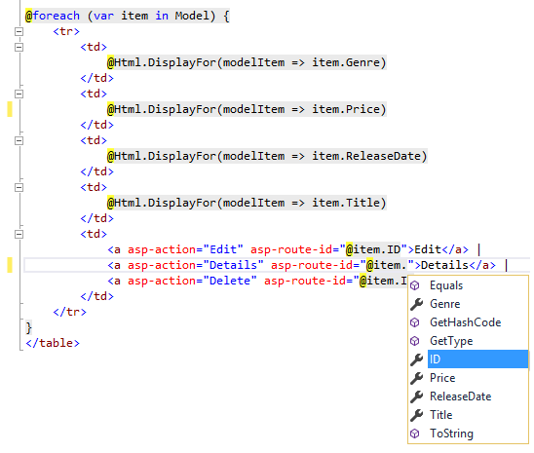

Work with SQL Server LocalDB in ASP.NET Core
The MvcMovieContext object handles the task of connecting to the database and mapping Movie objects to database records. The database context is registered with the Dependency Injection container in the ConfigureServices method in the Startup.cs file:
public void ConfigureServices(IServiceCollection services)
{
// Add framework services.
services.AddMvc();

services.AddDbContext<MvcMovieContext>(options =>
options.UseSqlServer(Configuration.GetConnectionString("MvcMovieContext")));
}
The ASP.NET Core Configuration system reads the ConnectionString. For local development, it gets the connection string from the appsettings.jsonfile:
"ConnectionStrings": {
"MvcMovieContext": "Server=(localdb)\\mssqllocaldb;Database=MvcMovieContext-2;Trusted_Connection=True;MultipleActiveResultSets=true"
}
When you deploy the app to a test or production server, you can use an environment variable or another approach to set the connection string to a real SQL Server. See Configuration for more information.

SQL Server Express LocalDB
LocalDB is a lightweight version of the SQL Server Express Database Engine that's targeted for program development. LocalDB starts on demand and runs in user mode, so there's no complex configuration. By default, LocalDB database creates "*.mdf" files in the C:/Users/<user> directory.
- From the View menu, open SQL Server Object Explorer (SSOX).
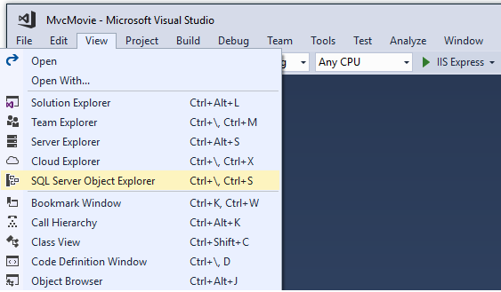
- Right click on the Movie table > View Designer
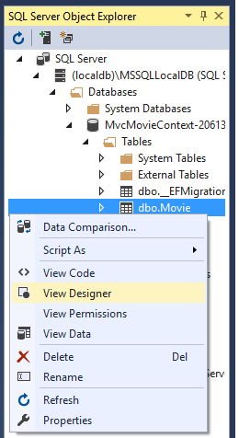
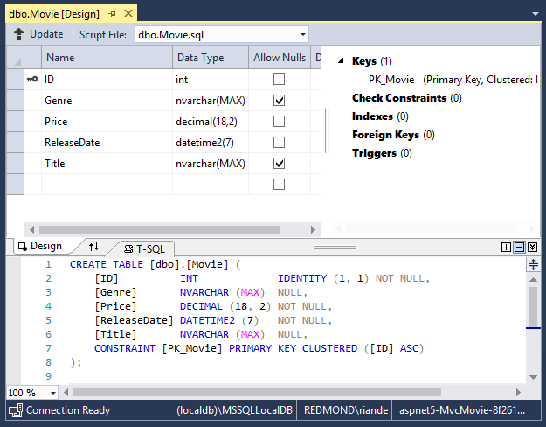
Note the key icon next to ID. By default, EF will make a property named ID the primary key.
- Right click on the Movie table > View Data
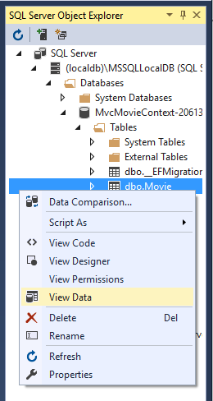
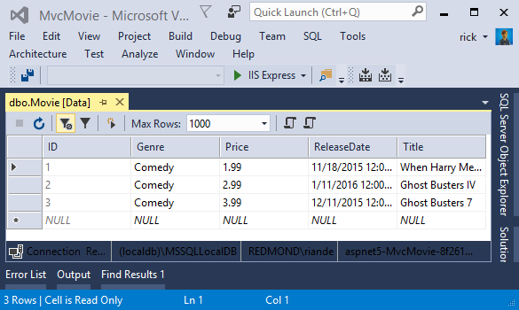

Seed the database
Create a new class named SeedData in the Models folder. Replace the generated code with the following:
using Microsoft.EntityFrameworkCore;
using Microsoft.Extensions.DependencyInjection;
using System;
using System.Linq;

namespace MvcMovie.Models
{
public static class SeedData
{
public static void Initialize(IServiceProvider serviceProvider)
{
using (var context = new MvcMovieContext(
serviceProvider.GetRequiredService<DbContextOptions<MvcMovieContext>>()))
{
// Look for any movies.
if (context.Movie.Any())
{
return; // DB has been seeded
}

context.Movie.AddRange(
new Movie
{
Title = "When Harry Met Sally",
ReleaseDate = DateTime.Parse("1989-1-11"),
Genre = "Romantic Comedy",
Price = 7.99M
},

new Movie
{
Title = "Ghostbusters ",
ReleaseDate = DateTime.Parse("1984-3-13"),
Genre = "Comedy",
Price = 8.99M
},

new Movie
{
Title = "Ghostbusters 2",
ReleaseDate = DateTime.Parse("1986-2-23"),
Genre = "Comedy",
Price = 9.99M
},

new Movie
{
Title = "Rio Bravo",
ReleaseDate = DateTime.Parse("1959-4-15"),
Genre = "Western",
Price = 3.99M
}
);
context.SaveChanges();
}
}
}
}
If there are any movies in the DB, the seed initializer returns and no movies are added.
if (context.Movie.Any())
{
return; // DB has been seeded.
}

Add the seed initializer
Add the seed initializer to the Main method in the Program.cs file:
using Microsoft.AspNetCore;
using Microsoft.AspNetCore.Hosting;
using Microsoft.Extensions.DependencyInjection;
using Microsoft.Extensions.Logging;
using MvcMovie.Models;
using System;

namespace MvcMovie
{
public class Program
{
public static void Main(string[] args)
{
var host = BuildWebHost(args);

using (var scope = host.Services.CreateScope())
{
var services = scope.ServiceProvider;

try
{
// Requires using MvcMovie.Models;
SeedData.Initialize(services);
}
catch (Exception ex)
{
var logger = services.GetRequiredService<ILogger<Program>>();
logger.LogError(ex, "An error occurred seeding the DB.");
}
}

host.Run();
}

public static IWebHost BuildWebHost(string[] args) =>
WebHost.CreateDefaultBuilder(args)
.UseStartup<Startup>()
.Build();
}
}
Test the app
- Delete all the records in the DB. You can do this with the delete links in the browser or from SSOX.
- Force the app to initialize (call the methods in the Startup class) so the seed method runs. To force initialization, IIS Express must be stopped and restarted. You can do this with any of the following approaches:
  - Right click the IIS Express system tray icon in the notification area and tap Exit or Stop Site
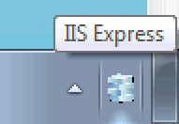
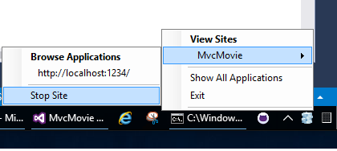
    - If you were running VS in non-debug mode, press F5 to run in debug mode
    - If you were running VS in debug mode, stop the debugger and press F5
The app shows the seeded data.
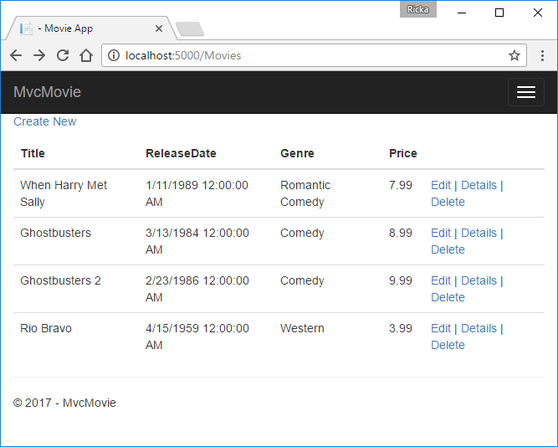

Controller methods and views in ASP.NET Core
We have a good start to the movie app, but the presentation isn't ideal. We don't want to see the time (12:00:00 AM in the image below) and ReleaseDate should be two words.
Open the Models/Movie.cs file and add the highlighted lines shown below:
using System;
using System.Collections.Generic;
using System.Linq;
using System.Threading.Tasks;

namespace MvcMovie.Models
{
public class Movie
{
public int ID { get; set; }
public string Title { get; set; }

[Display(Name = "Release Date")]
[DataType(DataType.Date)]
public DateTime ReleaseDate { get; set; }
public string Genre { get; set; }
public decimal Price { get; set; }
}
}
Right click on a red squiggly line > Quick Actions and Refactorings.
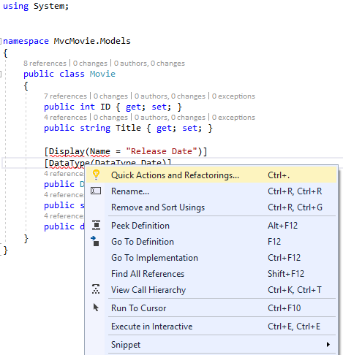
Tap using System.ComponentModel.DataAnnotations;
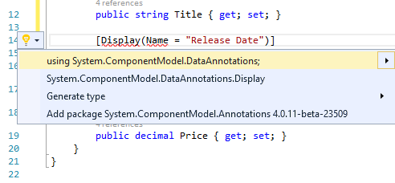
Visual studio adds using System.ComponentModel.DataAnnotations;.
Let's remove the using statements that are not needed. They show up by default in a light grey font. Right click anywhere in the Movie.cs file > Remove and Sort Usings.
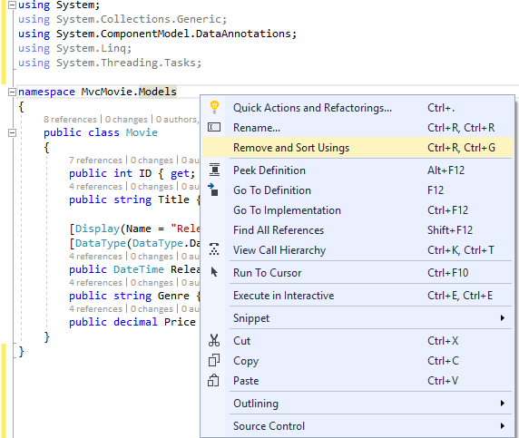
The updated code:
using System;
using System.ComponentModel.DataAnnotations;

namespace MvcMovie.Models
{
public class Movie
{
public int ID { get; set; }
public string Title { get; set; }

[Display(Name = "Release Date")]
[DataType(DataType.Date)]
public DateTime ReleaseDate { get; set; }
public string Genre { get; set; }
public decimal Price { get; set; }
}
}
We'll cover DataAnnotations in the next tutorial. The Display attribute specifies what to display for the name of a field (in this case "Release Date" instead of "ReleaseDate"). The DataType attribute specifies the type of the data (Date), so the time information stored in the field isn't displayed.
Browse to the Movies controller and hold the mouse pointer over an Edit link to see the target URL.
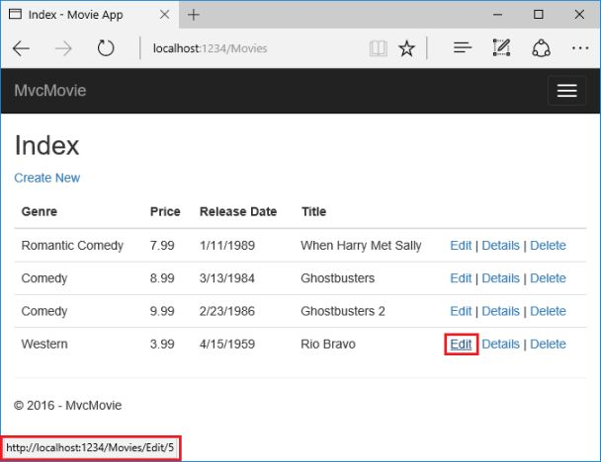
The Edit, Details, and Delete links are generated by the Core MVC Anchor Tag Helper in the Views/Movies/Index.cshtml file.
<a asp-action="Edit" asp-route-id="@item.ID">Edit</a> |
<a asp-action="Details" asp-route-id="@item.ID">Details</a> |
<a asp-action="Delete" asp-route-id="@item.ID">Delete</a>
</td>
</tr>
Tag Helpers enable server-side code to participate in creating and rendering HTML elements in Razor files. In the code above, the AnchorTagHelperdynamically generates the HTML href attribute value from the controller action method and route id. You use View Source from your favorite browser or use the developer tools to examine the generated markup. A portion of the generated HTML is shown below:
<td>
<a href="/Movies/Edit/4"> Edit </a> |
<a href="/Movies/Details/4"> Details </a> |
<a href="/Movies/Delete/4"> Delete </a>
</td>
Recall the format for routing set in the Startup.cs file:
app.UseMvc(routes =>
{
routes.MapRoute(
name: "default",
template: "{controller=Home}/{action=Index}/{id?}");
});
ASP.NET Core translates http://localhost:1234/Movies/Edit/4 into a request to the Edit action method of the Movies controller with the parameter Id of 4. (Controller methods are also known as action methods.)
Tag Helpers are one of the most popular new features in ASP.NET Core. See Additional resources for more information.
Open the Movies controller and examine the two Edit action methods. The following code shows the HTTP GET Edit method, which fetches the movie and populates the edit form generated by the Edit.cshtml Razor file.
// GET: Movies/Edit/5
public async Task<IActionResult> Edit(int? id)
{
if (id == null)
{
return NotFound();
}

var movie = await _context.Movie.SingleOrDefaultAsync(m => m.ID == id);
if (movie == null)
{
return NotFound();
}
return View(movie);
}
The following code shows the HTTP POST Edit method, which processes the posted movie values:
// POST: Movies/Edit/5
// To protect from overposting attacks, please enable the specific properties you want to bind to, for
// more details see http://go.microsoft.com/fwlink/?LinkId=317598.
[HttpPost]
[ValidateAntiForgeryToken]
public async Task<IActionResult> Edit(int id, [Bind("ID,Title,ReleaseDate,Genre,Price")] Movie movie)
{
if (id != movie.ID)
{
return NotFound();
}

if (ModelState.IsValid)
{
try
{
_context.Update(movie);
await _context.SaveChangesAsync();
}
catch (DbUpdateConcurrencyException)
{
if (!MovieExists(movie.ID))
{
return NotFound();
}
else
{
throw;
}
}
return RedirectToAction("Index");
}
return View(movie);
}
The [Bind] attribute is one way to protect against over-posting. You should only include properties in the [Bind] attribute that you want to change. See Protect your controller from over-posting for more information. ViewModels provide an alternative approach to prevent over-posting.
Notice the second Edit action method is preceded by the [HttpPost] attribute.
// POST: Movies/Edit/5
// To protect from overposting attacks, please enable the specific properties you want to bind to, for
// more details see http://go.microsoft.com/fwlink/?LinkId=317598.
[HttpPost]
[ValidateAntiForgeryToken]
public async Task<IActionResult> Edit(int id, [Bind("ID,Title,ReleaseDate,Genre,Price")] Movie movie)
{
if (id != movie.ID)
{
return NotFound();
}

if (ModelState.IsValid)
{
try
{
_context.Update(movie);
await _context.SaveChangesAsync();
}
catch (DbUpdateConcurrencyException)
{
if (!MovieExists(movie.ID))
{
return NotFound();
}
else
{
throw;
}
}
return RedirectToAction("Index");
}
return View(movie);
}
The HttpPost attribute specifies that this Edit method can be invoked only for POST requests. You could apply the [HttpGet] attribute to the first edit method, but that's not necessary because [HttpGet] is the default.
The ValidateAntiForgeryToken attribute is used to prevent forgery of a request and is paired up with an anti-forgery token generated in the edit view file (Views/Movies/Edit.cshtml). The edit view file generates the anti-forgery token with the Form Tag Helper.
<form asp-action="Edit">
The Form Tag Helper generates a hidden anti-forgery token that must match the [ValidateAntiForgeryToken] generated anti-forgery token in the Edit method of the Movies controller. For more information, see Anti-Request Forgery.
The HttpGet Edit method takes the movie ID parameter, looks up the movie using the Entity Framework SingleOrDefaultAsync method, and returns the selected movie to the Edit view. If a movie cannot be found, NotFound (HTTP 404) is returned.
// GET: Movies/Edit/5
public async Task<IActionResult> Edit(int? id)
{
if (id == null)
{
return NotFound();
}

var movie = await _context.Movie.SingleOrDefaultAsync(m => m.ID == id);
if (movie == null)
{
return NotFound();
}
return View(movie);
}
When the scaffolding system created the Edit view, it examined the Movie class and created code to render <label> and <input> elements for each property of the class. The following example shows the Edit view that was generated by the Visual Studio scaffolding system:
@model MvcMovie.Models.Movie

@{
ViewData["Title"] = "Edit";
}

<h2>Edit</h2>

<form asp-action="Edit">
<div class="form-horizontal">
<h4>Movie</h4>
<hr />
<div asp-validation-summary="ModelOnly" class="text-danger"></div>
<input type="hidden" asp-for="ID" />
<div class="form-group">
<label asp-for="Title" class="col-md-2 control-label"></label>
<div class="col-md-10">
<input asp-for="Title" class="form-control" />
<span asp-validation-for="Title" class="text-danger"></span>
</div>
</div>
<div class="form-group">
<label asp-for="ReleaseDate" class="col-md-2 control-label"></label>
<div class="col-md-10">
<input asp-for="ReleaseDate" class="form-control" />
<span asp-validation-for="ReleaseDate" class="text-danger"></span>
</div>
</div>
<div class="form-group">
<label asp-for="Genre" class="col-md-2 control-label"></label>
<div class="col-md-10">
<input asp-for="Genre" class="form-control" />
<span asp-validation-for="Genre" class="text-danger"></span>
</div>
</div>
<div class="form-group">
<label asp-for="Price" class="col-md-2 control-label"></label>
<div class="col-md-10">
<input asp-for="Price" class="form-control" />
<span asp-validation-for="Price" class="text-danger"></span>
</div>
</div>
<div class="form-group">
<div class="col-md-offset-2 col-md-10">
<input type="submit" value="Save" class="btn btn-default" />
</div>
</div>
</div>
</form>

<div>
<a asp-action="Index">Back to List</a>
</div>

@section Scripts {
@{await Html.RenderPartialAsync("_ValidationScriptsPartial");}
}
Notice how the view template has a @model MvcMovie.Models.Movie statement at the top of the file. @model MvcMovie.Models.Movie specifies that the view expects the model for the view template to be of type Movie.
The scaffolded code uses several Tag Helper methods to streamline the HTML markup. The - Label Tag Helper displays the name of the field ("Title", "ReleaseDate", "Genre", or "Price"). The Input Tag Helper renders an HTML <input> element. The Validation Tag Helper displays any validation messages associated with that property.
Run the application and navigate to the /Movies URL. Click an Edit link. In the browser, view the source for the page. The generated HTML for the <form> element is shown below.
<form action="/Movies/Edit/7" method="post">
<div class="form-horizontal">
<h4>Movie</h4>
<hr />
<div class="text-danger" />
<input type="hidden" data-val="true" data-val-required="The ID field is required." id="ID" name="ID" value="7" />
<div class="form-group">
<label class="control-label col-md-2" for="Genre" />
<div class="col-md-10">
<input class="form-control" type="text" id="Genre" name="Genre" value="Western" />
<span class="text-danger field-validation-valid" data-valmsg-for="Genre" data-valmsg-replace="true"></span>
</div>
</div>
<div class="form-group">
<label class="control-label col-md-2" for="Price" />
<div class="col-md-10">
<input class="form-control" type="text" data-val="true" data-val-number="The field Price must be a number." data-val-required="The Price field is required." id="Price" name="Price" value="3.99" />
<span class="text-danger field-validation-valid" data-valmsg-for="Price" data-valmsg-replace="true"></span>
</div>
</div>
<!-- Markup removed for brevity -->
<div class="form-group">
<div class="col-md-offset-2 col-md-10">
<input type="submit" value="Save" class="btn btn-default" />
</div>
</div>
</div>
<input name="__RequestVerificationToken" type="hidden" value="CfDJ8Inyxgp63fRFqUePGvuI5jGZsloJu1L7X9le1gy7NCIlSduCRx9jDQClrV9pOTTmqUyXnJBXhmrjcUVDJyDUMm7-MF_9rK8aAZdRdlOri7FmKVkRe_2v5LIHGKFcTjPrWPYnc9AdSbomkiOSaTEg7RU" />
</form>
The <input> elements are in an HTML <form> element whose action attribute is set to post to the /Movies/Edit/id URL. The form data will be posted to the server when the Save button is clicked. The last line before the closing </form> element shows the hidden XSRF token generated by the Form Tag Helper.

Processing the POST Request
The following listing shows the [HttpPost] version of the Edit action method.
// POST: Movies/Edit/5
// To protect from overposting attacks, please enable the specific properties you want to bind to, for
// more details see http://go.microsoft.com/fwlink/?LinkId=317598.
[HttpPost]
[ValidateAntiForgeryToken]
public async Task<IActionResult> Edit(int id, [Bind("ID,Title,ReleaseDate,Genre,Price")] Movie movie)
{
if (id != movie.ID)
{
return NotFound();
}

if (ModelState.IsValid)
{
try
{
_context.Update(movie);
await _context.SaveChangesAsync();
}
catch (DbUpdateConcurrencyException)
{
if (!MovieExists(movie.ID))
{
return NotFound();
}
else
{
throw;
}
}
return RedirectToAction("Index");
}
return View(movie);
}
The [ValidateAntiForgeryToken] attribute validates the hidden XSRF token generated by the anti-forgery token generator in the Form Tag Helper
The model binding system takes the posted form values and creates a Movie object that's passed as the movie parameter. The ModelState.IsValidmethod verifies that the data submitted in the form can be used to modify (edit or update) a Movie object. If the data is valid it's saved. The updated (edited) movie data is saved to the database by calling the SaveChangesAsync method of database context. After saving the data, the code redirects the user to the Index action method of the MoviesController class, which displays the movie collection, including the changes just made.
Before the form is posted to the server, client side validation checks any validation rules on the fields. If there are any validation errors, an error message is displayed and the form isn't posted. If JavaScript is disabled, you won't have client side validation but the server will detect the posted values that are not valid, and the form values will be redisplayed with error messages. Later in the tutorial we examine Model Validation in more detail. The Validation Tag Helper in the Views/Movies/Edit.cshtml view template takes care of displaying appropriate error messages.
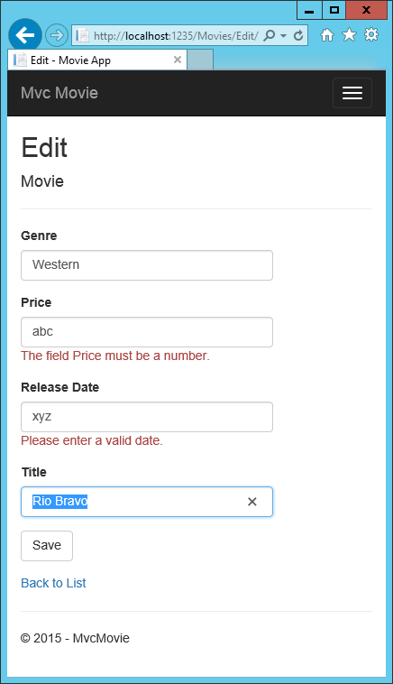
All the HttpGet methods in the movie controller follow a similar pattern. They get a movie object (or list of objects, in the case of Index), and pass the object (model) to the view. The Create method passes an empty movie object to the Create view. All the methods that create, edit, delete, or otherwise modify data do so in the [HttpPost] overload of the method. Modifying data in an HTTP GET method is a security risk. Modifying data in an HTTP GET method also violates HTTP best practices and the architectural REST pattern, which specifies that GET requests shouldn't change the state of your application. In other words, performing a GET operation should be a safe operation that has no side effects and doesn't modify your persisted data.

Adding Search to an ASP.NET Core MVC app
In this section you add search capability to the Index action method that lets you search movies by genre or name.
Update the Index method with the following code:
public async Task<IActionResult> Index(string searchString)
{
var movies = from m in _context.Movie
select m;

if (!String.IsNullOrEmpty(searchString))
{
movies = movies.Where(s => s.Title.Contains(searchString));
}

return View(await movies.ToListAsync());
}
The first line of the Index action method creates a LINQ query to select the movies:
var movies = from m in _context.Movie
select m;
The query is only defined at this point, it has not been run against the database.
If the searchString parameter contains a string, the movies query is modified to filter on the value of the search string:
if (!String.IsNullOrEmpty(searchString))
{
movies = movies.Where(s => s.Title.Contains(searchString));
}
The s => s.Title.Contains() code above is a Lambda Expression. Lambdas are used in method-based LINQ queries as arguments to standard query operator methods such as the Where method or Contains (used in the code above). LINQ queries are not executed when they're defined or when they're modified by calling a method such as Where, Contains or OrderBy. Rather, query execution is deferred. That means that the evaluation of an expression is delayed until its realized value is actually iterated over or the ToListAsync method is called. For more information about deferred query execution, see Query Execution.
Note: The Contains method is run on the database, not in the c# code shown above. The case sensitivity on the query depends on the database and the collation. On SQL Server, Contains maps to SQL LIKE, which is case insensitive. In SQLlite, with the default collation, it's case sensitive.
Navigate to /Movies/Index. Append a query string such as ?searchString=Ghost to the URL. The filtered movies are displayed.
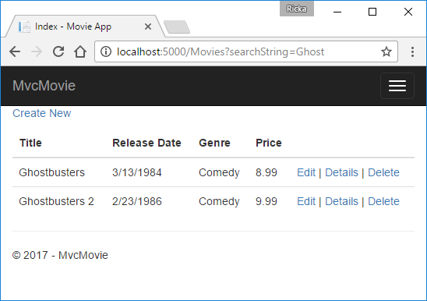
If you change the signature of the Index method to have a parameter named id, the id parameter will match the optional {id} placeholder for the default routes set in Startup.cs.
app.UseMvc(routes =>
{
routes.MapRoute(
name: "default",
template: "{controller=Home}/{action=Index}/{id?}");
});
You can quickly rename the searchString parameter to id with the rename command. Right click on searchString > Rename.
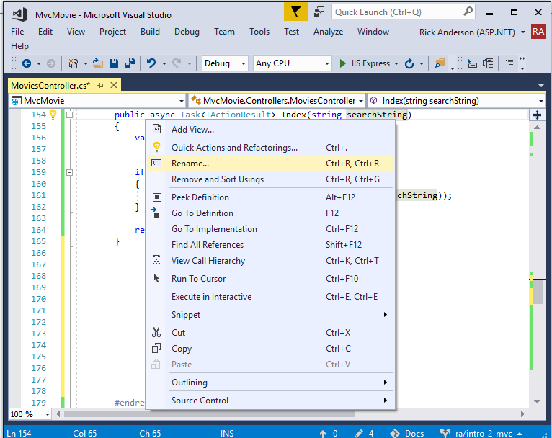
The rename targets are highlighted.
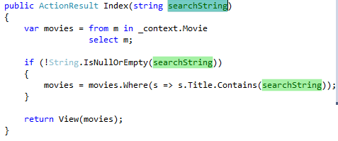
Change the parameter to id and all occurrences of searchString change to id.
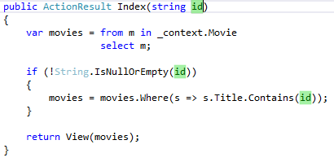
The previous Index method:
public async Task<IActionResult> Index(string searchString)
{
var movies = from m in _context.Movie
select m;

if (!String.IsNullOrEmpty(searchString))
{
movies = movies.Where(s => s.Title.Contains(searchString));
}

return View(await movies.ToListAsync());
}
The updated Index method with id parameter:
public async Task<IActionResult> Index(string id)
{
var movies = from m in _context.Movie
select m;

if (!String.IsNullOrEmpty(id))
{
movies = movies.Where(s => s.Title.Contains(id));
}

return View(await movies.ToListAsync());
}
You can now pass the search title as route data (a URL segment) instead of as a query string value.
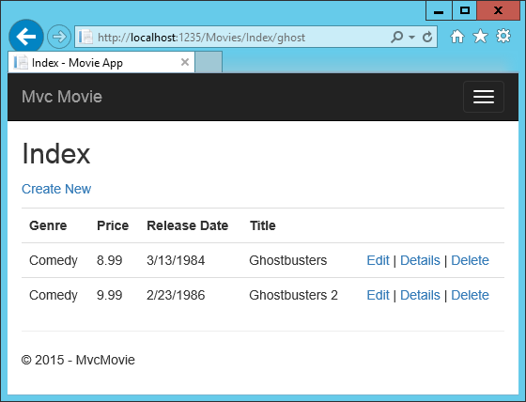
However, you can't expect users to modify the URL every time they want to search for a movie. So now you'll add UI elements to help them filter movies. If you changed the signature of the Index method to test how to pass the route-bound ID parameter, change it back so that it takes a parameter named searchString:
public async Task<IActionResult> Index(string searchString)
{
var movies = from m in _context.Movie
select m;

if (!String.IsNullOrEmpty(searchString))
{
movies = movies.Where(s => s.Title.Contains(searchString));
}

return View(await movies.ToListAsync());
}
Open the Views/Movies/Index.cshtml file, and add the <form> markup highlighted below:
ViewData["Title"] = "Index";
}

<h2>Index</h2>

<p>
<a asp-action="Create">Create New</a>
</p>

<form asp-controller="Movies" asp-action="Index">
<p>
Title: <input type="text" name="SearchString">
<input type="submit" value="Filter" />
</p>
</form>

<table class="table">
<thead>
The HTML <form> tag uses the Form Tag Helper, so when you submit the form, the filter string is posted to the Index action of the movies controller. Save your changes and then test the filter.
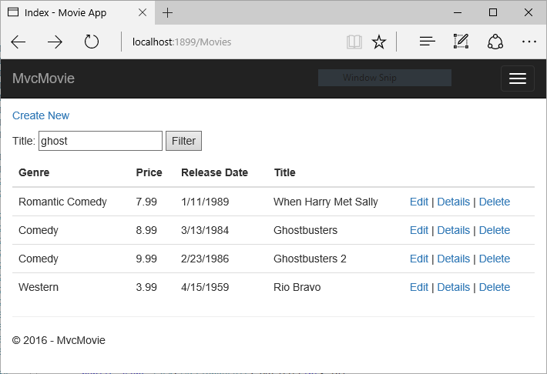
There's no [HttpPost] overload of the Index method as you might expect. You don't need it, because the method isn't changing the state of the app, just filtering data.
You could add the following [HttpPost] Index method.
[HttpPost]
public string Index(string searchString, bool notUsed)
{
return "From [HttpPost]Index: filter on " + searchString;
}
The notUsed parameter is used to create an overload for the Index method. We'll talk about that later in the tutorial.
If you add this method, the action invoker would match the [HttpPost] Index method, and the [HttpPost] Index method would run as shown in the image below.
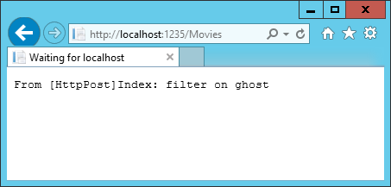
However, even if you add this [HttpPost] version of the Index method, there's a limitation in how this has all been implemented. Imagine that you want to bookmark a particular search or you want to send a link to friends that they can click in order to see the same filtered list of movies. Notice that the URL for the HTTP POST request is the same as the URL for the GET request (localhost:xxxxx/Movies/Index) -- there's no search information in the URL. The search string information is sent to the server as a form field value. You can verify that with the browser Developer tools or the excellent Fiddler tool. The image below shows the Chrome browser Developer tools:
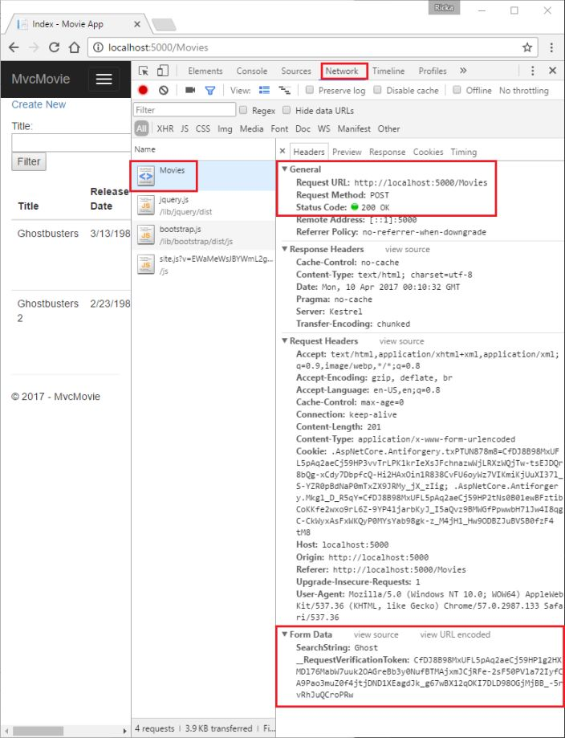
You can see the search parameter and XSRF token in the request body. Note, as mentioned in the previous tutorial, the Form Tag Helper generates an XSRF anti-forgery token. We're not modifying data, so we don't need to validate the token in the controller method.
Because the search parameter is in the request body and not the URL, you can't capture that search information to bookmark or share with others. We'll fix this by specifying the request should be HTTP GET.
Notice how intelliSense helps us update the markup.
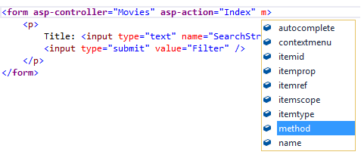
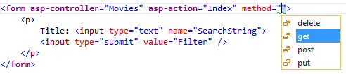
Notice the distinctive font in the <form> tag. That distinctive font indicates the tag is supported by Tag Helpers.
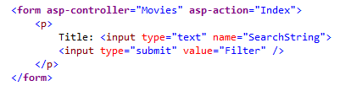
Now when you submit a search, the URL contains the search query string. Searching will also go to the HttpGet Index action method, even if you have a HttpPost Index method.
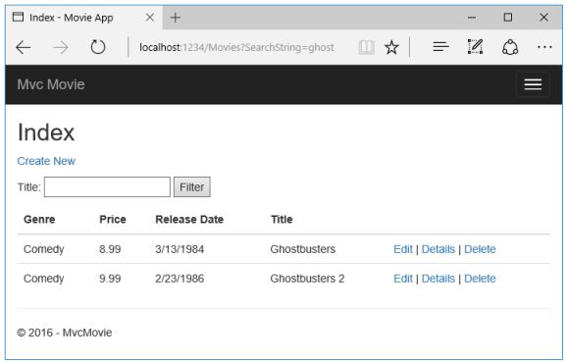
The following markup shows the change to the form tag:
<form asp-controller="Movies" asp-action="Index" method="get">

Adding Search by genre
Add the following MovieGenreViewModel class to the Models folder:
using Microsoft.AspNetCore.Mvc.Rendering;
using System.Collections.Generic;

namespace MvcMovie.Models
{
public class MovieGenreViewModel
{
public List<Movie> movies;
public SelectList genres;
public string movieGenre { get; set; }
}
}
The movie-genre view model will contain:
- A list of movies.
- A SelectList containing the list of genres. This will allow the user to select a genre from the list.
- movieGenre, which contains the selected genre.
Replace the Index method in MoviesController.cs with the following code:
// Requires using Microsoft.AspNetCore.Mvc.Rendering;
public async Task<IActionResult> Index(string movieGenre, string searchString)
{
// Use LINQ to get list of genres.
IQueryable<string> genreQuery = from m in _context.Movie
orderby m.Genre
select m.Genre;

var movies = from m in _context.Movie
select m;

if (!String.IsNullOrEmpty(searchString))
{
movies = movies.Where(s => s.Title.Contains(searchString));
}

if (!String.IsNullOrEmpty(movieGenre))
{
movies = movies.Where(x => x.Genre == movieGenre);
}

var movieGenreVM = new MovieGenreViewModel();
movieGenreVM.genres = new SelectList(await genreQuery.Distinct().ToListAsync());
movieGenreVM.movies = await movies.ToListAsync();

return View(movieGenreVM);
}
The following code is a LINQ query that retrieves all the genres from the database.
// Use LINQ to get list of genres.
IQueryable<string> genreQuery = from m in _context.Movie
orderby m.Genre
select m.Genre;
The SelectList of genres is created by projecting the distinct genres (we don't want our select list to have duplicate genres).
movieGenreVM.genres = new SelectList(await genreQuery.Distinct().ToListAsync())

Adding search by genre to the Index view
Update Index.cshtml as follows:
@model MvcMovie.Models.MovieGenreViewModel

@{
ViewData["Title"] = "Index";
}

<h2>Index</h2>

<p>
<a asp-action="Create">Create New</a>
</p>

<form asp-controller="Movies" asp-action="Index" method="get">
<p>
<select asp-for="movieGenre" asp-items="Model.genres">
<option value="">All</option>
</select>

Title: <input type="text" name="SearchString">
<input type="submit" value="Filter" />
</p>
</form>

<table class="table">
<thead>
<tr>
<th>
@Html.DisplayNameFor(model => model.movies[0].Title)
</th>
<th>
@Html.DisplayNameFor(model => model.movies[0].ReleaseDate)
</th>
<th>
@Html.DisplayNameFor(model => model.movies[0].Genre)
</th>
<th>
@Html.DisplayNameFor(model => model.movies[0].Price)
</th>
<th></th>
</tr>
</thead>
<tbody>
@foreach (var item in Model.movies)
{
<tr>
<td>
@Html.DisplayFor(modelItem => item.Title)
</td>
<td>
@Html.DisplayFor(modelItem => item.ReleaseDate)
</td>
<td>
@Html.DisplayFor(modelItem => item.Genre)
</td>
<td>
@Html.DisplayFor(modelItem => item.Price)
</td>
<td>
<a asp-action="Edit" asp-route-id="@item.ID">Edit</a> |
<a asp-action="Details" asp-route-id="@item.ID">Details</a> |
<a asp-action="Delete" asp-route-id="@item.ID">Delete</a>
</td>
</tr>
}
</tbody>
</table>
Examine the lambda expression used in the following HTML Helper:
@Html.DisplayNameFor(model => model.movies[0].Title)
In the preceding code, the DisplayNameFor HTML Helper inspects the Title property referenced in the lambda expression to determine the display name. Since the lambda expression is inspected rather than evaluated, you don't receive an access violation when model, model.movies, or model.movies[0] are null or empty. When the lambda expression is evaluated (for example, @Html.DisplayFor(modelItem => item.Title)), the model's property values are evaluated.
Test the app by searching by genre, by movie title, and by both.

Add a new field to an ASP.NET Core app
In this section you'll use Entity Framework Code First Migrations to add a new field to the model and migrate that change to the database.
When you use EF Code First to automatically create a database, Code First adds a table to the database to help track whether the schema of the database is in sync with the model classes it was generated from. If they aren't in sync, EF throws an exception. This makes it easier to find inconsistent database/code issues.

Adding a Rating Property to the Movie Model
Open the Models/Movie.cs file and add a Rating property:
public class Movie
{
public int ID { get; set; }
public string Title { get; set; }

[Display(Name = "Release Date")]
[DataType(DataType.Date)]
public DateTime ReleaseDate { get; set; }
public string Genre { get; set; }
public decimal Price { get; set; }
public string Rating { get; set; }
}
Build the app (Ctrl+Shift+B).
Because you've added a new field to the Movie class, you also need to update the binding white list so this new property will be included. In MoviesController.cs, update the [Bind] attribute for both the Create and Edit action methods to include the Rating property:
[Bind("ID,Title,ReleaseDate,Genre,Price,Rating")]
You also need to update the view templates in order to display, create and edit the new Rating property in the browser view.
Edit the /Views/Movies/Index.cshtml file and add a Rating field:
<table class="table">
<thead>
<tr>
<th>
@Html.DisplayNameFor(model => model.movies[0].Title)
</th>
<th>
@Html.DisplayNameFor(model => model.movies[0].ReleaseDate)
</th>
<th>
@Html.DisplayNameFor(model => model.movies[0].Genre)
</th>
<th>
@Html.DisplayNameFor(model => model.movies[0].Price)
</th>
<th>
@Html.DisplayNameFor(model => model.movies[0].Rating)
</th>
<th></th>
</tr>
</thead>
<tbody>
@foreach (var item in Model.movies)
{
<tr>
<td>
@Html.DisplayFor(modelItem => item.Title)
</td>
<td>
@Html.DisplayFor(modelItem => item.ReleaseDate)
</td>
<td>
@Html.DisplayFor(modelItem => item.Genre)
</td>
<td>
@Html.DisplayFor(modelItem => item.Price)
</td>
<td>
@Html.DisplayFor(modelItem => item.Rating)
</td>
<td>
Update the /Views/Movies/Create.cshtml with a Rating field. You can copy/paste the previous "form group" and let intelliSense help you update the fields. IntelliSense works with Tag Helpers. Note: In the RTM verison of Visual Studio 2017 you need to install the Razor Language Services for Razor intelliSense. This will be fixed in the next release.
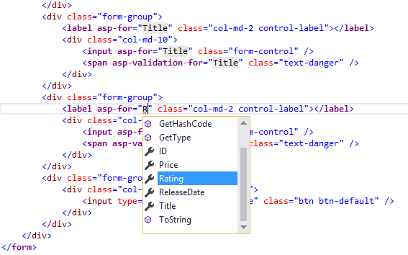
The app won't work until we update the DB to include the new field. If you run it now, you'll get the following SqlException:
SqlException: Invalid column name 'Rating'.
You're seeing this error because the updated Movie model class is different than the schema of the Movie table of the existing database. (There's no Rating column in the database table.)
There are a few approaches to resolving the error:
- Have the Entity Framework automatically drop and re-create the database based on the new model class schema. This approach is very convenient early in the development cycle when you are doing active development on a test database; it allows you to quickly evolve the model and database schema together. The downside, though, is that you lose existing data in the database — so you don't want to use this approach on a production database! Using an initializer to automatically seed a database with test data is often a productive way to develop an application.
- Explicitly modify the schema of the existing database so that it matches the model classes. The advantage of this approach is that you keep your data. You can make this change either manually or by creating a database change script.
- Use Code First Migrations to update the database schema.
For this tutorial, we'll use Code First Migrations.
Update the SeedData class so that it provides a value for the new column. A sample change is shown below, but you'll want to make this change for each new Movie.
new Movie
{
Title = "When Harry Met Sally",
ReleaseDate = DateTime.Parse("1989-1-11"),
Genre = "Romantic Comedy",
Rating = "R",
Price = 7.99M
},
Build the solution.
From the Tools menu, select NuGet Package Manager > Package Manager Console.
In the PMC, enter the following commands:
Add-Migration Rating
Update-Database
The Add-Migration command tells the migration framework to examine the current Movie model with the current Movie DB schema and create the necessary code to migrate the DB to the new model. The name "Rating" is arbitrary and is used to name the migration file. It's helpful to use a meaningful name for the migration file.
If you delete all the records in the DB, the initialize will seed the DB and include the Rating field. You can do this with the delete links in the browser or from SSOX.
Run the app and verify you can create/edit/display movies with a Rating field. You should also add the Rating field to the Edit, Details, and Delete view templates.

Adding validation
In this section you'll add validation logic to the Movie model, and you'll ensure that the validation rules are enforced any time a user creates or edits a movie.

Keeping things DRY
One of the design tenets of MVC is DRY ("Don't Repeat Yourself"). ASP.NET MVC encourages you to specify functionality or behavior only once, and then have it be reflected everywhere in an app. This reduces the amount of code you need to write and makes the code you do write less error prone, easier to test, and easier to maintain.
The validation support provided by MVC and Entity Framework Core Code First is a good example of the DRY principle in action. You can declaratively specify validation rules in one place (in the model class) and the rules are enforced everywhere in the app.

Adding validation rules to the movie model
Open the Movie.cs file. DataAnnotations provides a built-in set of validation attributes that you apply declaratively to any class or property. (It also contains formatting attributes like DataType that help with formatting and don't provide any validation.)
Update the Movie class to take advantage of the built-in Required, StringLength, RegularExpression, and Range validation attributes.
public class Movie
{
public int ID { get; set; }

[StringLength(60, MinimumLength = 3)]
[Required]
public string Title { get; set; }

[Display(Name = "Release Date")]
[DataType(DataType.Date)]
public DateTime ReleaseDate { get; set; }

[Range(1, 100)]
[DataType(DataType.Currency)]
public decimal Price { get; set; }

[RegularExpression(@"^[A-Z]+[a-zA-Z""'\s-]*$")]
[Required]
[StringLength(30)]
public string Genre { get; set; }

[RegularExpression(@"^[A-Z]+[a-zA-Z""'\s-]*$")]
[StringLength(5)]
[Required]
public string Rating { get; set; }
}
The validation attributes specify behavior that you want to enforce on the model properties they're applied to. The Required and MinimumLengthattributes indicates that a property must have a value; but nothing prevents a user from entering white space to satisfy this validation. The RegularExpression attribute is used to limit what characters can be input. In the code above, Genre and Rating must use only letters (white space, numbers and special characters are not allowed). The Range attribute constrains a value to within a specified range. The StringLength attribute lets you set the maximum length of a string property, and optionally its minimum length. Value types (such as decimal, int, float, DateTime) are inherently required and don't need the [Required] attribute.
Having validation rules automatically enforced by ASP.NET helps make your app more robust. It also ensures that you can't forget to validate something and inadvertently let bad data into the database.

Validation Error UI in MVC
Run the app and navigate to the Movies controller.
Tap the Create New link to add a new movie. Fill out the form with some invalid values. As soon as jQuery client side validation detects the error, it displays an error message.
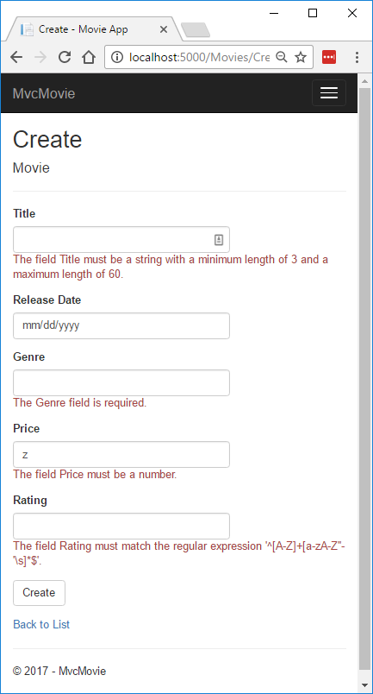
Note
You may not be able to enter decimal commas in the Price field. To support jQuery validation for non-English locales that use a comma (",") for a decimal point, and non US-English date formats, you must take steps to globalize your app. This GitHub issue 4076 for instructions on adding decimal comma.
Notice how the form has automatically rendered an appropriate validation error message in each field containing an invalid value. The errors are enforced both client-side (using JavaScript and jQuery) and server-side (in case a user has JavaScript disabled).
A significant benefit is that you didn't need to change a single line of code in the MoviesController class or in the Create.cshtml view in order to enable this validation UI. The controller and views you created earlier in this tutorial automatically picked up the validation rules that you specified by using validation attributes on the properties of the Movie model class. Test validation using the Edit action method, and the same validation is applied.
The form data isn't sent to the server until there are no client side validation errors. You can verify this by putting a break point in the HTTP Postmethod, by using the Fiddler tool , or the F12 Developer tools.

How validation works
You might wonder how the validation UI was generated without any updates to the code in the controller or views. The following code shows the two Create methods.
// GET: Movies/Create
public IActionResult Create()
{
return View();
}

// POST: Movies/Create
[HttpPost]
[ValidateAntiForgeryToken]
public async Task<IActionResult> Create(
[Bind("ID,Title,ReleaseDate,Genre,Price, Rating")] Movie movie)
{
if (ModelState.IsValid)
{
_context.Add(movie);
await _context.SaveChangesAsync();
return RedirectToAction("Index");
}
return View(movie);
}
The first (HTTP GET) Create action method displays the initial Create form. The second ([HttpPost]) version handles the form post. The second Create method (The [HttpPost] version) calls ModelState.IsValid to check whether the movie has any validation errors. Calling this method evaluates any validation attributes that have been applied to the object. If the object has validation errors, the Create method re-displays the form. If there are no errors, the method saves the new movie in the database. In our movie example, the form isn't posted to the server when there are validation errors detected on the client side; the second Create method is never called when there are client side validation errors. If you disable JavaScript in your browser, client validation is disabled and you can test the HTTP POST Create method ModelState.IsValid detecting any validation errors.
You can set a break point in the [HttpPost] Create method and verify the method is never called, client side validation won't submit the form data when validation errors are detected. If you disable JavaScript in your browser, then submit the form with errors, the break point will be hit. You still get full validation without JavaScript.
The following image shows how to disable JavaScript in the FireFox browser.
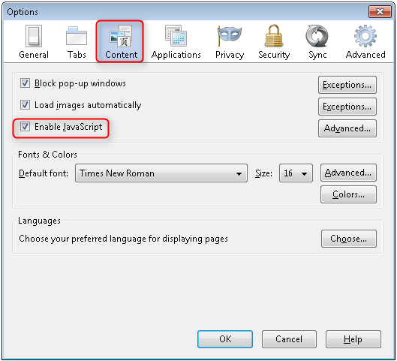
The following image shows how to disable JavaScript in the Chrome browser.
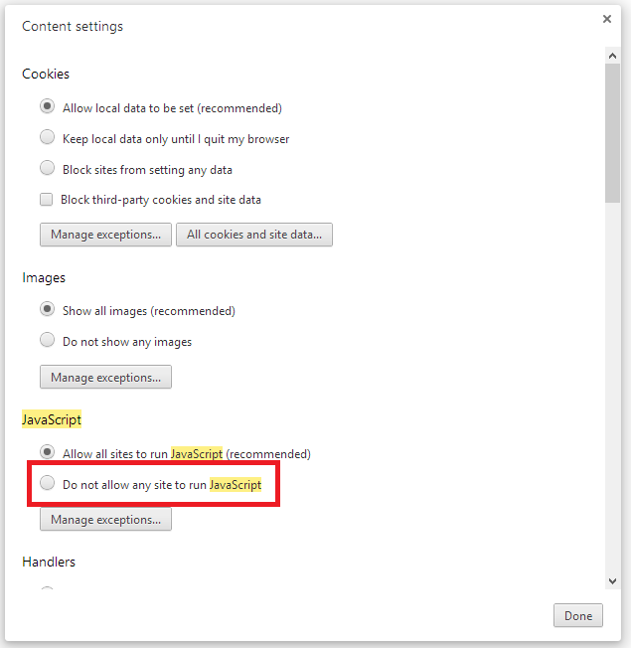
After you disable JavaScript, post invalid data and step through the debugger.
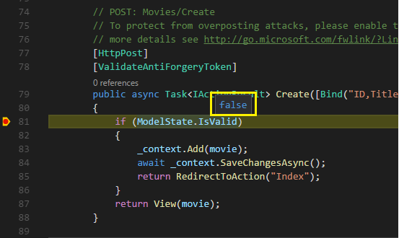
Below is portion of the Create.cshtml view template that you scaffolded earlier in the tutorial. It's used by the action methods shown above both to display the initial form and to redisplay it in the event of an error.
<form asp-action="Create">
<div class="form-horizontal">
<h4>Movie</h4>
<hr />

<div asp-validation-summary="ModelOnly" class="text-danger"></div>
<div class="form-group">
<label asp-for="Title" class="col-md-2 control-label"></label>
<div class="col-md-10">
<input asp-for="Title" class="form-control" />
<span asp-validation-for="Title" class="text-danger"></span>
</div>
</div>

@*Markup removed for brevity.*@
</div>
</form>
The Input Tag Helper uses the DataAnnotations attributes and produces HTML attributes needed for jQuery Validation on the client side. The Validation Tag Helper displays validation errors. See Validation for more information.
What's really nice about this approach is that neither the controller nor the Create view template knows anything about the actual validation rules being enforced or about the specific error messages displayed. The validation rules and the error strings are specified only in the Movie class. These same validation rules are automatically applied to the Edit view and any other views templates you might create that edit your model.
When you need to change validation logic, you can do so in exactly one place by adding validation attributes to the model (in this example, the Movie class). You won't have to worry about different parts of the application being inconsistent with how the rules are enforced — all validation logic will be defined in one place and used everywhere. This keeps the code very clean, and makes it easy to maintain and evolve. And it means that you'll be fully honoring the DRY principle.

Using DataType Attributes
Open the Movie.cs file and examine the Movie class. The System.ComponentModel.DataAnnotations namespace provides formatting attributes in addition to the built-in set of validation attributes. We've already applied a DataType enumeration value to the release date and to the price fields. The following code shows the ReleaseDate and Price properties with the appropriate DataType attribute.
[Display(Name = "Release Date")]
[DataType(DataType.Date)]
public DateTime ReleaseDate { get; set; }

[Range(1, 100)]
[DataType(DataType.Currency)]
public decimal Price { get; set; }
The DataType attributes only provide hints for the view engine to format the data (and supplies elements/attributes such as <a> for URL's and <a href="mailto:EmailAddress.com"> for email. You can use the RegularExpression attribute to validate the format of the data. The DataTypeattribute is used to specify a data type that's more specific than the database intrinsic type, they're not validation attributes. In this case we only want to keep track of the date, not the time. The DataType Enumeration provides for many data types, such as Date, Time, PhoneNumber, Currency, EmailAddress and more. The DataType attribute can also enable the application to automatically provide type-specific features. For example, a mailto: link can be created for DataType.EmailAddress, and a date selector can be provided for DataType.Date in browsers that support HTML5. The DataType attributes emits HTML 5 data- (pronounced data dash) attributes that HTML 5 browsers can understand. The DataType attributes do not provide any validation.
DataType.Date doesn't specify the format of the date that's displayed. By default, the data field is displayed according to the default formats based on the server's CultureInfo.
The DisplayFormat attribute is used to explicitly specify the date format:
[DisplayFormat(DataFormatString = "{0:yyyy-MM-dd}", ApplyFormatInEditMode = true)]
public DateTime ReleaseDate { get; set; }
The ApplyFormatInEditMode setting specifies that the formatting should also be applied when the value is displayed in a text box for editing. (You might not want that for some fields — for example, for currency values, you probably don't want the currency symbol in the text box for editing.)
You can use the DisplayFormat attribute by itself, but it's generally a good idea to use the DataType attribute. The DataType attribute conveys the semantics of the data as opposed to how to render it on a screen, and provides the following benefits that you don't get with DisplayFormat:
- The browser can enable HTML5 features (for example to show a calendar control, the locale-appropriate currency symbol, email links, etc.)
- By default, the browser will render data using the correct format based on your locale.
- The DataType attribute can enable MVC to choose the right field template to render the data (the DisplayFormat if used by itself uses the string template).
Note
jQuery validation doesn't work with the Range attribute and DateTime. For example, the following code will always display a client side validation error, even when the date is in the specified range:
[Range(typeof(DateTime), "1/1/1966", "1/1/2020")]
You will need to disable jQuery date validation to use the Range attribute with DateTime. It's generally not a good practice to compile hard dates in your models, so using the Range attribute and DateTime is discouraged.
The following code shows combining attributes on one line:
public class Movie
{
public int ID { get; set; }

[StringLength(60, MinimumLength = 3)]
public string Title { get; set; }

[Display(Name = "Release Date"), DataType(DataType.Date)]
public DateTime ReleaseDate { get; set; }

[RegularExpression(@"^[A-Z]+[a-zA-Z""'\s-]*$"), Required, StringLength(30)]
public string Genre { get; set; }

[Range(1, 100), DataType(DataType.Currency)]
public decimal Price { get; set; }

[RegularExpression(@"^[A-Z]+[a-zA-Z""'\s-]*$"), StringLength(5)]
public string Rating { get; set; }
}
In the next part of the series, we'll review the application and make some improvements to the automatically generated Details and Deletemethods.

Examine the Details and Delete methods of an ASP.NET Core app
Open the Movie controller and examine the Details method:
// GET: Movies/Details/5
public async Task<IActionResult> Details(int? id)
{
if (id == null)
{
return NotFound();
}

var movie = await _context.Movie
.SingleOrDefaultAsync(m => m.ID == id);
if (movie == null)
{
return NotFound();
}

return View(movie);
}
The MVC scaffolding engine that created this action method adds a comment showing an HTTP request that invokes the method. In this case it's a GET request with three URL segments, the Movies controller, the Details method and an id value. Recall these segments are defined in Startup.cs.
app.UseMvc(routes =>
{
routes.MapRoute(
name: "default",
template: "{controller=Home}/{action=Index}/{id?}");
});
EF makes it easy to search for data using the SingleOrDefaultAsync method. An important security feature built into the method is that the code verifies that the search method has found a movie before it tries to do anything with it. For example, a hacker could introduce errors into the site by changing the URL created by the links from http://localhost:xxxx/Movies/Details/1 to something like http://localhost:xxxx/Movies/Details/12345(or some other value that doesn't represent an actual movie). If you didn't check for a null movie, the app would throw an exception.
Examine the Delete and DeleteConfirmed methods.
// GET: Movies/Delete/5
public async Task<IActionResult> Delete(int? id)
{
if (id == null)
{
return NotFound();
}

var movie = await _context.Movie
.SingleOrDefaultAsync(m => m.ID == id);
if (movie == null)
{
return NotFound();
}

return View(movie);
}

// POST: Movies/Delete/5
[HttpPost, ActionName("Delete")]
[ValidateAntiForgeryToken]
public async Task<IActionResult> DeleteConfirmed(int id)
{
var movie = await _context.Movie.SingleOrDefaultAsync(m => m.ID == id);
_context.Movie.Remove(movie);
await _context.SaveChangesAsync();
return RedirectToAction("Index");
}
Note that the HTTP GET Delete method doesn't delete the specified movie, it returns a view of the movie where you can submit (HttpPost) the deletion. Performing a delete operation in response to a GET request (or for that matter, performing an edit operation, create operation, or any other operation that changes data) opens up a security hole.
The [HttpPost] method that deletes the data is named DeleteConfirmed to give the HTTP POST method a unique signature or name. The two method signatures are shown below:
// GET: Movies/Delete/5
public async Task<IActionResult> Delete(int? id)
{
// POST: Movies/Delete/5
[HttpPost, ActionName("Delete")]
[ValidateAntiForgeryToken]
public async Task<IActionResult> DeleteConfirmed(int id)
{
The common language runtime (CLR) requires overloaded methods to have a unique parameter signature (same method name but different list of parameters). However, here you need two Delete methods -- one for GET and one for POST -- that both have the same parameter signature. (They both need to accept a single integer as a parameter.)
There are two approaches to this problem, one is to give the methods different names. That's what the scaffolding mechanism did in the preceding example. However, this introduces a small problem: ASP.NET maps segments of a URL to action methods by name, and if you rename a method, routing normally wouldn't be able to find that method. The solution is what you see in the example, which is to add the ActionName("Delete")attribute to the DeleteConfirmed method. That attribute performs mapping for the routing system so that a URL that includes /Delete/ for a POST request will find the DeleteConfirmed method.
Another common work around for methods that have identical names and signatures is to artificially change the signature of the POST method to include an extra (unused) parameter. That's what we did in a previous post when we added the notUsed parameter. You could do the same thing here for the [HttpPost] Delete method:
// POST: Movies/Delete/6
[ValidateAntiForgeryToken]
public async Task<IActionResult> Delete(int id, bool notUsed)

Publish to Azure
See Publish an ASP.NET Core web app to Azure App Service using Visual Studio for instructions on how to publish this app to Azure using Visual Studio. The app can also be published from the command line.
Thanks for completing this introduction to ASP.NET Core MVC. We appreciate any comments you leave. Get started with MVC and EF Core is an excellent follow up to this tutorial.

